Mental Health Care Analysis

EDA (Exploratory Data Analysis) Project
- Understanding the Problems/Dataset
This dataset studies how social media use affects the mental health of teenagers. It includes daily habits like social media hours, sleep, stress, anxiety, and physical activity. The goal is to understand if high social media use is linked with problems like stress, anxiety, and depression.
- Importing necessary libraries
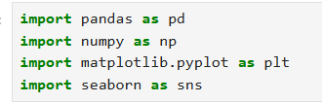
- Load the Dataset
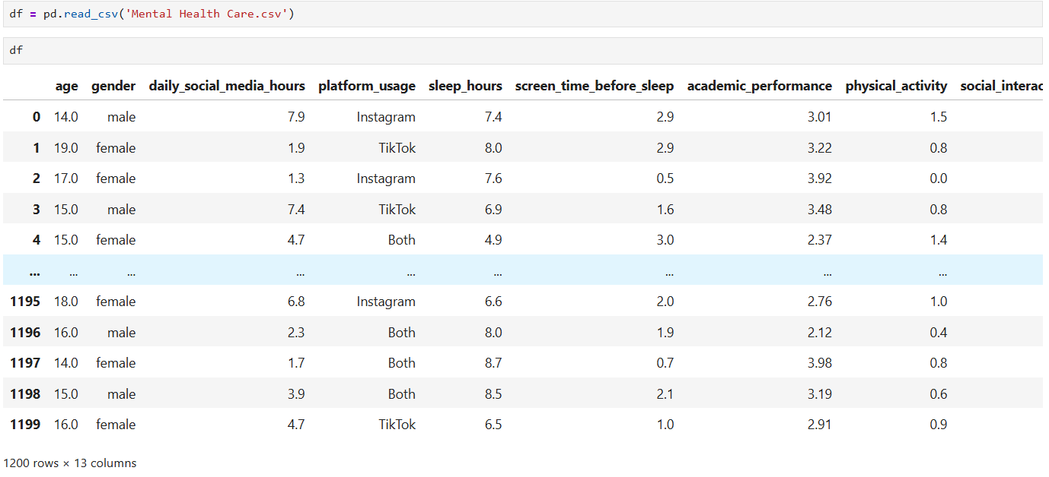

- Data Info:
To look up the basic Dataframe stats and missing values
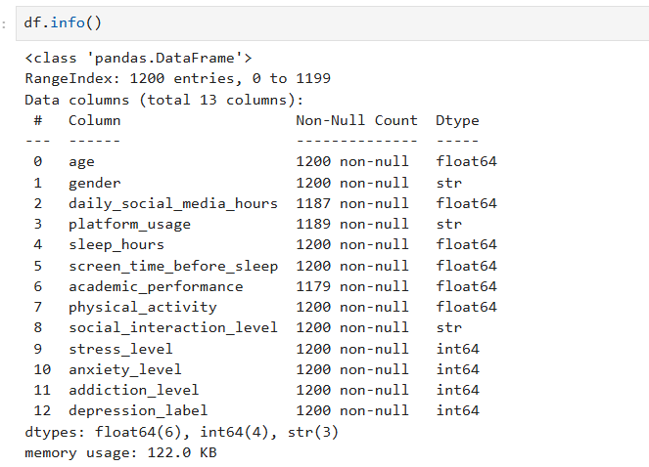

- Check Duplicates values
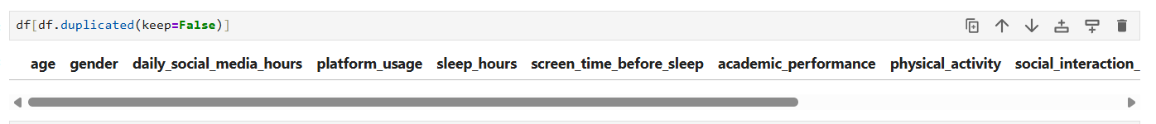

Observation: their is no duplicates values found in the data.

- Missing values check
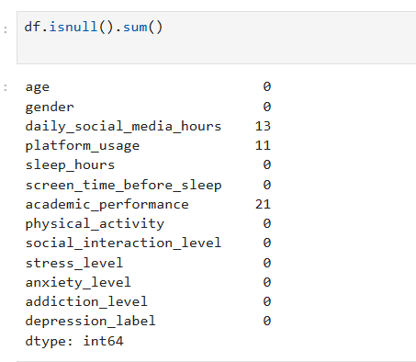
Observation: The columns daily social media hours, platform usage, and academic performance has some missing values.
- Pre-processing of data

- Removing the duplicates values
Observation: In the data there is no duplicates values exist.

- Change the datatypes
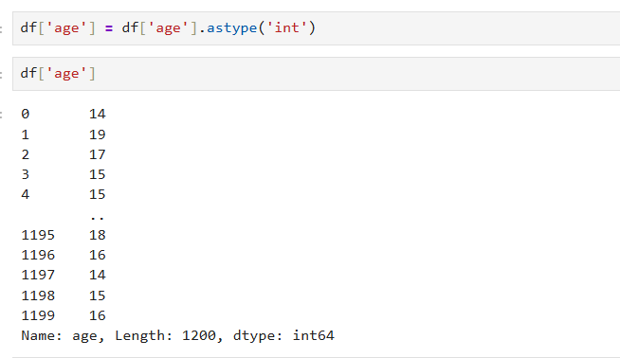
Observation: The Datatype of Age column is in Float so i converted it into integer.
- Handling the missing values
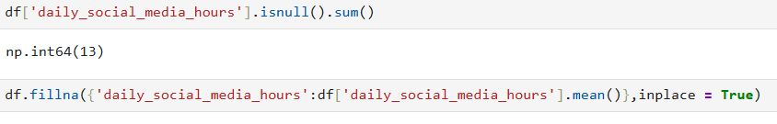
Observation: The null values in the daily social media hours column is fill by the mean value.

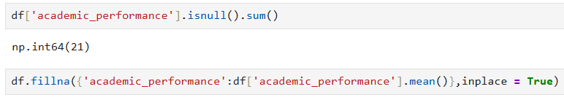
Observation: The null values in the academic performance column is fill by the mean value.

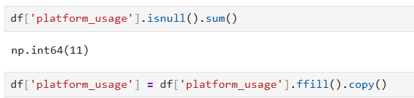
Observation:
- The null values in the platform usage column is fill by the forward fill method.
- Forward fill replaces missing values with the previous non-missing value.

- Column Data Type Assignment
Observation: This help the user to know which columns are categorical and which are numeric. It also helps to predict the target column.

- Exploring Data & Visualization

- The Total percentage of men and women in the data
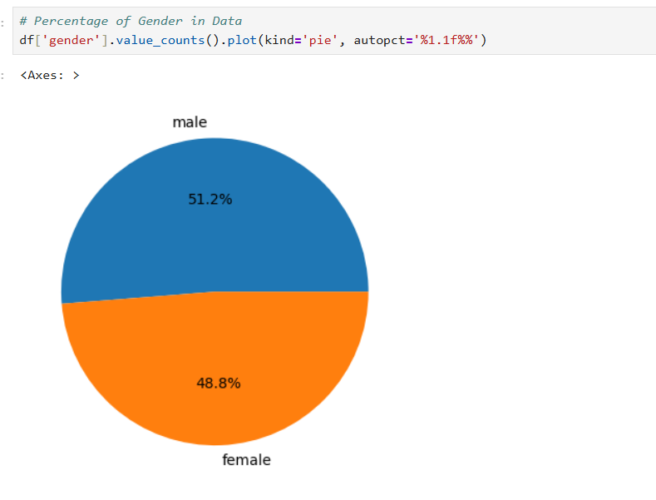
Observation: The percentage of Male gender is more than the Female gender in the data

- The Total sleep hours on the basis of genders
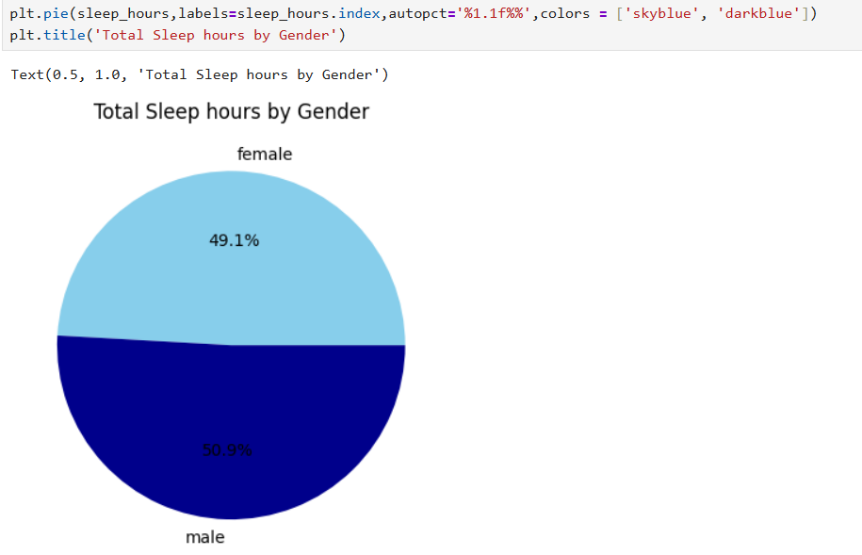
Observation: There is a slight difference between the Total Sleep hours of Male and Female gender.
- The Total hours spend by the children daily on social media platforms
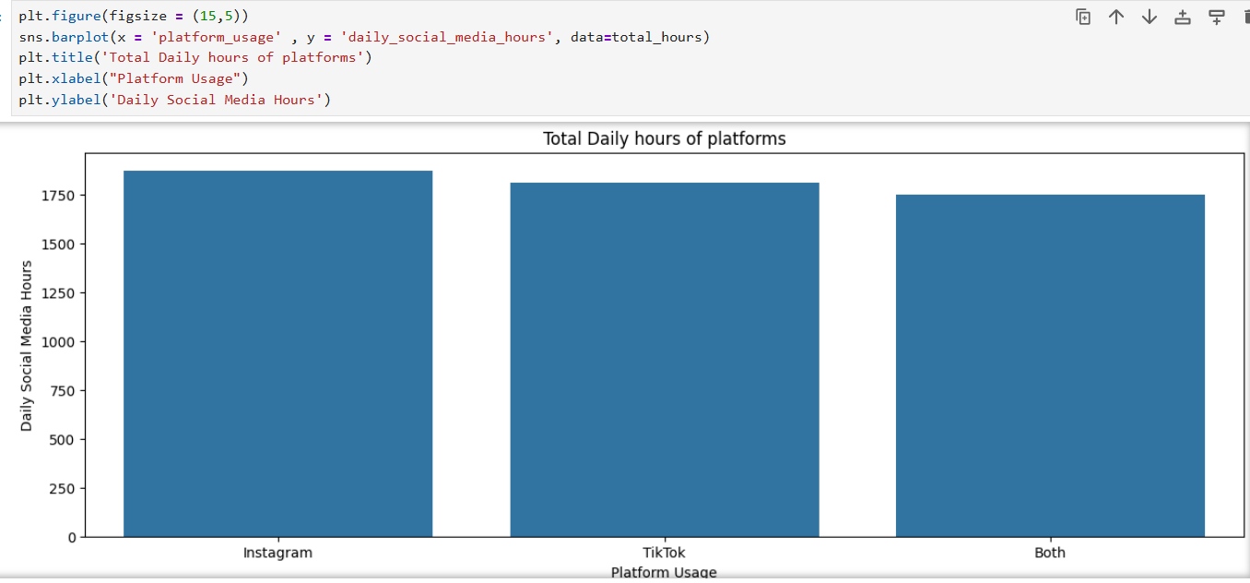
Observation: The teenagers like to spend most of their daily hours in Instagram as compare to TikTok.

- The Total count values of the platforms in the data
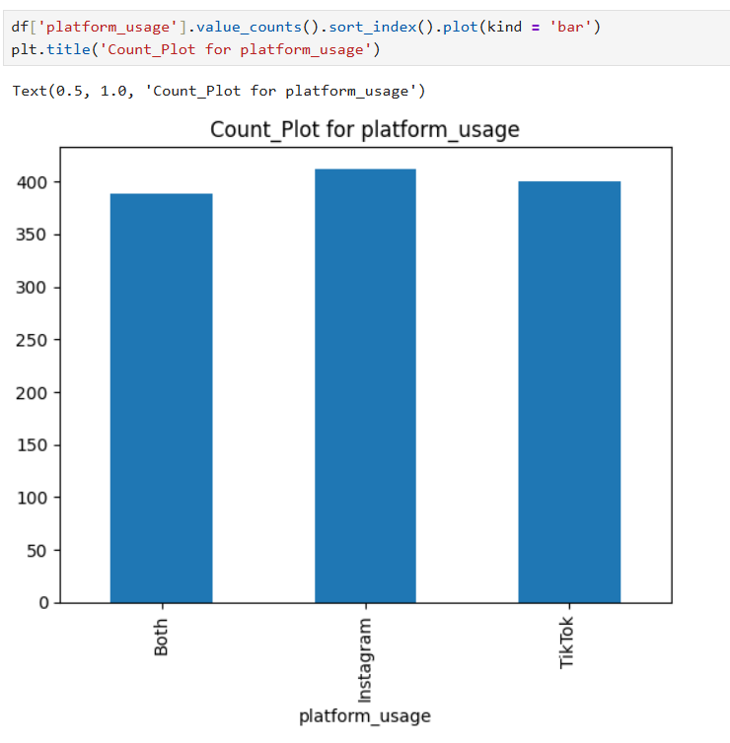
Observation: The Platform Instagram has the higher value as compared to TikTok and both.

- The Total values in the depression level column in data

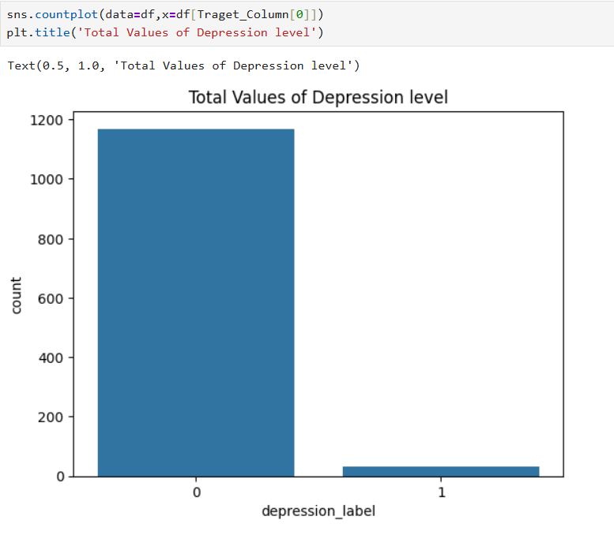
Observation: The dataset is highly imbalanced class 0(almost 1150) has significantly more samples than class 1(almost 50) which has very few entries.
- The Graph shows the how values of ages are distributed by genders
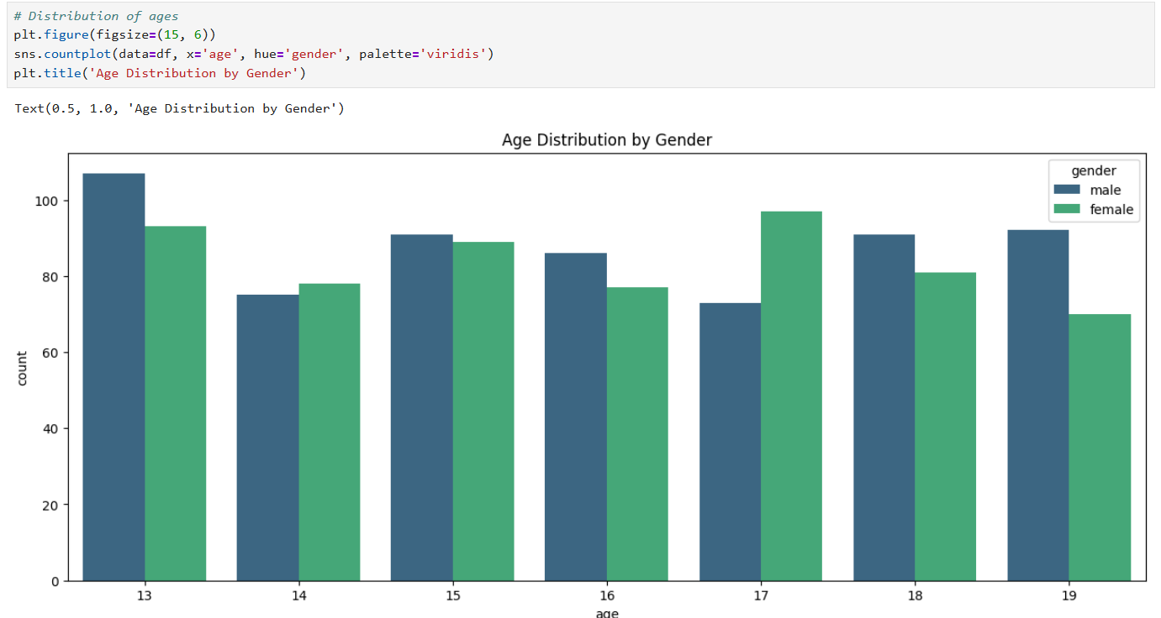

Observation: The dataset shows slightly variations in age distribution between genders, with no extreme differences across most age groups.

- The Graph shows the total sleep hours of different ages
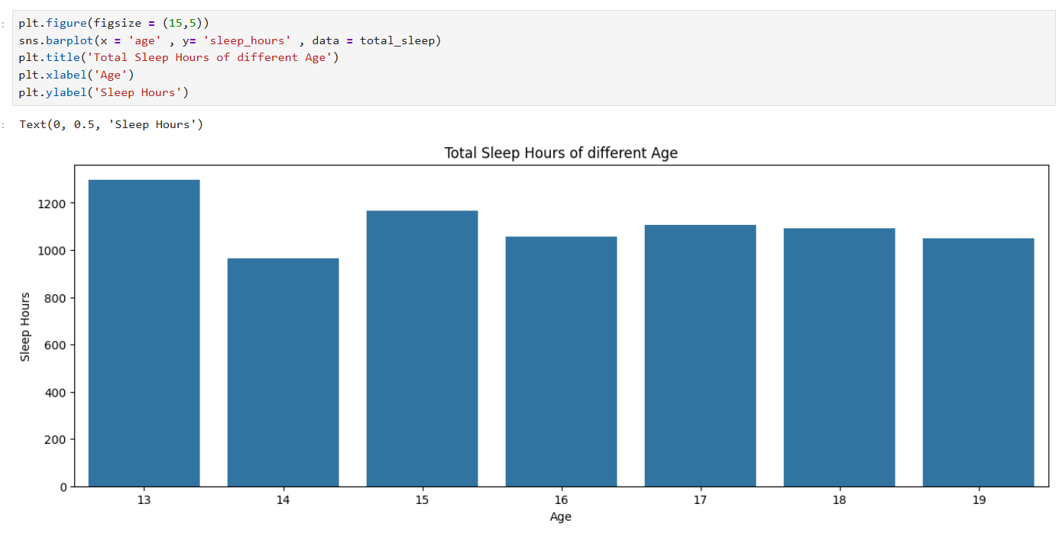
Observation: The age 14 years has the lowest total daily sleep hours, below 1000 hours.
- The total values of social interaction level of different ages
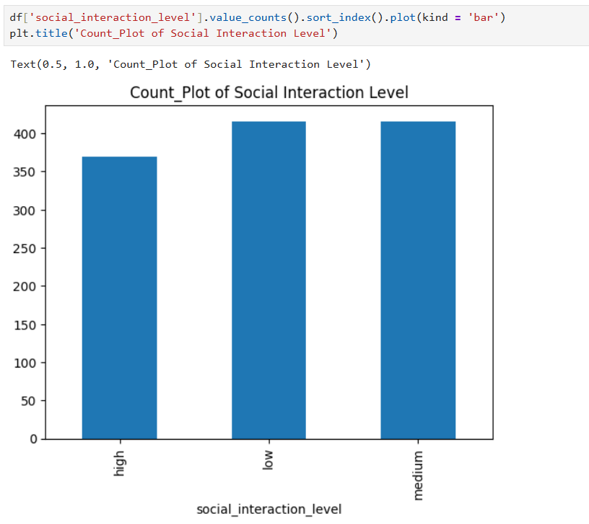
Observation: The data suggests that the majority of individuals fall into the medium to low social interaction range.

- This Graph shows at which stress level the depression level is occurs
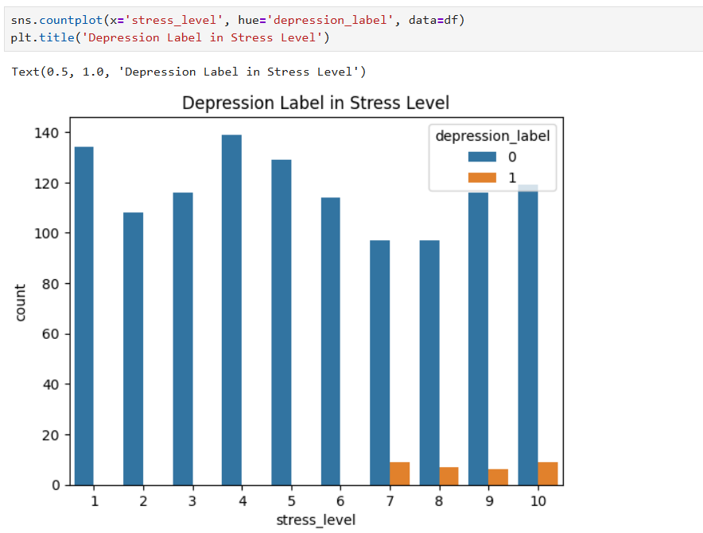
Observation: The depression cases start appearing more noticeable at higher stress levels (7-10).

- What are the depression level in the gender column in the data?
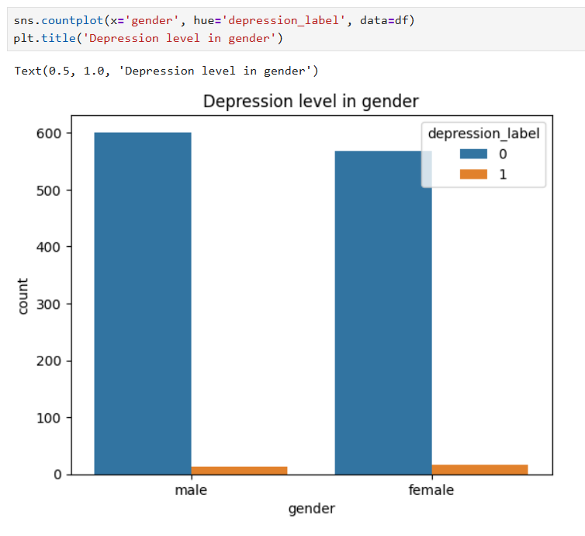

Observation: The graph is highly imbalanced because non-depressed cases are much larger than depressed cases.

- This Heatmap shows the numeric columns correlation to find relation between columns
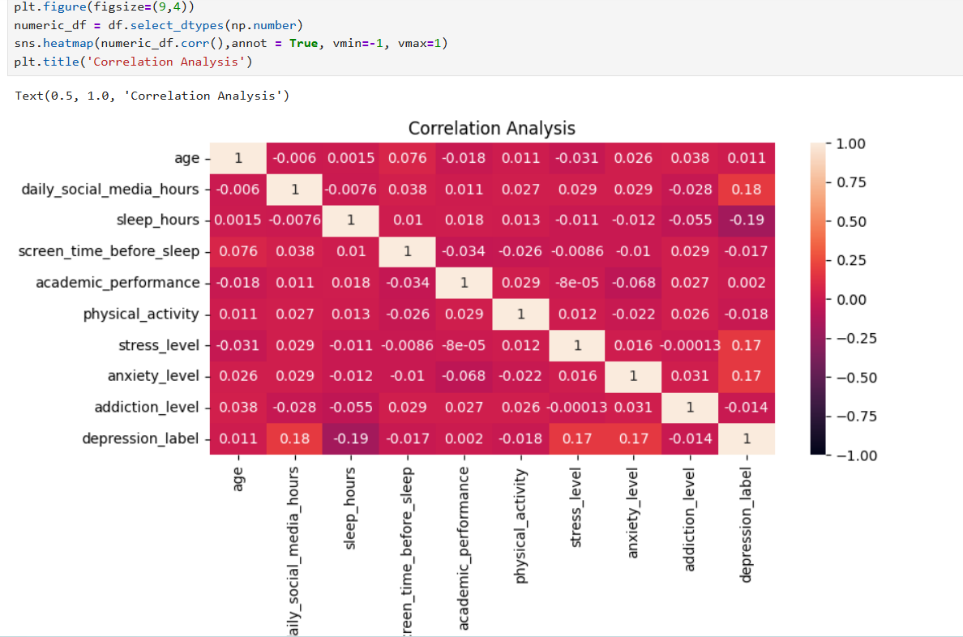

Observation:
- Weak Overall Correlations: Most of the values in this dataset are very close to zero (e.g., 0.0015, -0.014). This suggests that, in this specific dataset, these factors do not have strong linear relationships with one another.

- Depression level has a slight positive correlation with daily social media hours (0.18), stress level (0.17), and anxiety level (0.17), indicating these factors may slightly increase depression risk.

- Sleep Hours vs. Addiction Level (-0.055): Weak negative relationship. It suggests that as addiction levels (likely social media/internet) increase, hours of sleep tend to decrease slightly.

Key Insights:
- Higher social media usage (especially before sleep) is associated with lower sleep duration and higher stress/anxiety.
- The teenagers using multiple social media platforms like Instagram, TikTok which leads to higher addiction level and depression scores in them.

- Stress and anxiety level has a negative correlation with academic performance, as increase in stress and anxiety leads to decrease in academic performance.

- The depressed teens has higher stress, anxiety, screen time, less sleep, addiction level as compared to non-depressed teens.

Tools & Technologies Used:
- Jupyter Notebook

- Python 3.x

- Pandas: Structured data analysis, data cleaning, filtering, and data frame manipulation.

- NumPy: High-performance mathematical operations and multi-dimensional array processing

- Matplotlib: Core library for creating static, publication-quality 2D plots.

- Seaborn: Advanced statistical data visualization built on top of Matplotlib

Conclusion
The data analysis indicates that social media usage has a noticeable impact on teenagers’ mental health and daily lifestyle patterns. Platforms like Instagram were found to be the most commonly used, while higher screen time showed a slight association with increased stress, anxiety, and depression levels. The study also suggests that excessive social media engagement may affect sleep quality and reduce healthy social interactions. Although the correlations are mostly weak to moderate, the overall findings highlight the importance of balanced social media usage and maintaining healthy habits to support better mental well-being among teenagers.

